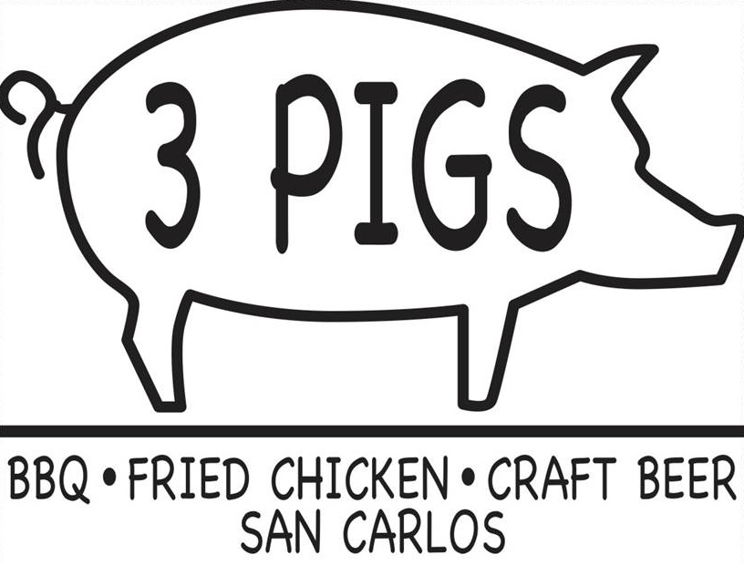

CATERING
Catering is served family style and dropped off hot and ready to serve at the time of delivery.
Chaffing dishes, coolers, ice available for an additional set up fee.
Please choose 1,2,3 or 4 meats for your entire party we cannot accommodate individual selections.
Our catering is based on the average appetite if your party includes some larger appetites you may consider ordering extra meals.

Slow Smoked BBQ Platters
Choose 1,2,3 or 4 Meats and 3 House Made Sides
1 Meat plus 3 House Made Sides…………………………………………………………………………………..$16.99 per person
2 Meat plus 3 House Made Sides…………………………………………………………………………………..$18.99 per person
3 Meat plus 3 House Made Sides…………………………………………………………………………………..$21.99 per person
4 Meat plus 3 House Made Sides…………………………………………………………………………………..$23.99 per person
Meats to choose from
St. Louis BBQ Ribs, Slow Smoked BBQ Chicken Breast, Slow Smoked BBQ Chicken Thigh and Drum, Certified Angus Beef USDA Prime Brisket*, North Carolina Pulled Pork, Schwartz Sausage Company of San Francisco Hot Link, Santa Maria Tri –Tip*, Slow Smoked Pulled Chicken.
(*add 1.00 per person for Brisket or Tri-Tip)
Vegetarian Options
BBQ Portobello Mushroom w/Onions and Bell Peppers (available as a meat choice in catering or a la carte for 10.00 per serving)
House Made Sides to Choose From
BBQ Baked Beans, Black Bean Corn Salad, Award Winning Chili, Coleslaw, Collard Greens, Creamed Corn, Baked Daily Cornbread Muffins & Butter, It’s NOT Kraft Mac & Cheese, Yukon Gold Potato Salad, Quinoa Salad, Tomato & Cucumber Salad, Kale Watermelon Feta Salad, Kale Cesar Salad, House Salad.
Fried Chicken Platters
Choose 2, 3 or 4 Pieces per person and 3 House Made Sides
2 Pieces (white or dark) plus 3 House Made Sides………………………………………………………..$15 per person
3 Pieces (white = 2 wings & 1 breast or dark = 1 thigh & 2 drumsticks) plus 3 House Made Sides…………………………………………………………………………………………………………………………….$17 per person
4 Pieces plus 3 House Made Sides (1 of each thigh, drumstick, breast & wing)…………… $19 per person
Buns
Buttered & Toasted La Boulanger Sandwich Buns……………………………………………………….. $1.20 each
Appetizers
Pig Candy (Candied Bacon) per order (4 Pieces)…………………………………………………………….$6.00
Deviled Eggs Tray ………………………………………………………………………………………………………..$12.50 per order (10 Pieces)

Client:____________ Date of Event:_______________ Contact #:_____________ Email:____________
Deposit
A 25% deposit is due at the time of booking.

Final Payment
Card info from deposit will be run on the day of the event for final payment based on the total amount agreed upon at the time of booking. If the total number of guests decreases after the time of booking the amount agreed upon at the time of booking will be charged regardless of the decrease in guests.

Cancelation
24 hours in advance: If the client cancels the catering, the deposit is non-refundable but can be applied to another catering event when that date and time are available.
Less than 24 hours: If the client cancels the catering with less than 24 hours’ notice, 50% of the agreed upon price at the time of booking is non-refundable but can be applied to another catering event when that date and time are available. The additional 50% will be forfeited to 3 Pigs BBQ.

Pricing
The bid given in this agreement will be valid for 30 days after such the prices may fluctuate.

Delivery/Set Up
18% Delivery/Set Up/Gratuity fee, Minimum of 20 guests; Includes delivery(within 12 miles), paper goods, plastic utensils, recyclable serving containers, recyclable serving utensils, placed in your serving area that has been pre-setup prior to delivery time.
Catering Details
# of Guests:________ Delivery or Pick Up Time:___________ Location:_____________________________
Order: ____________________________________________________________________________________________________________________________________________________________________________________________________
Payment:
25% Deposit Paid with: VISA MC AMEX DISCOVER CASH CHECK#_______________________________________
Card #:______________________________________ Exp. Date:_____________________________________________
Balance:
_______ Charged to the above Credit Card the day of the event
_______ Paid by Check or Cash the day of the event

Client Signature:_____________________ Date:________________________
I have read this contract and understand and agree to the rates and terms and conditions of this contract. Please complete fully, sign and return to 3pigbbq@gmail.com

3 Pigs BBQ sincerely appreciates your consideration in planning your special event. We love referrals and Yelp reviews! Thank you!

